March 13, 2024

The Honorable Maria Cantwell  Chair  Committee on Commerce, Science, & Transportation  Unites States Senate | The Honorable Ted Cruz  Ranking Member  Committee on Commerce, Science, & Transportation  Unites States Senate

Dear Chair Cantwell and Ranking Member Cruz,

The National Consumers League (NCL), the nation’s pioneering consumer advocacy organization, has spearheaded transparency and safeguards around consumer packaged goods for decades. In states and localities, NCL has had success in championing unit pricing efforts, allowing buyers to accurately comparison shop across options. In 2015, the League brought a lawsuit against McCormick Spice alleging that the company’s packaging intended to obfuscate the true amount and price of product, an illegal practice known as “slack-filling.” Now, NCL continues its work on behalf of consumers at the federal level, where there is no comprehensive unit pricing statute or regulation.

Business practices over the past few years have highlighted the alarming lack of nationwide safeguards regarding price transparency. As American consumers struggled with spiking inflation, companies posted steep profits, with some estimating that corporate greed drove over 50% of consumer price increases in the years following the pandemic. One of the methods businesses have employed to make more money has been to sell less product without lowering the price, a practice dubbed “shrinkflation.” From produce to cleaning products to toiletries, shrinkflation can deceive consumers into paying more than they normally would for the same goods they have purchased for years. Senator Bob Casey’s S.3819, the “Shrinkflation Prevention Act,” would make this practice illegal. NCL urges the Senate Committee on Commerce, Science, and Transportation to schedule a hearing and affirmatively report this legislation.

The overpricing of goods without obvious disclosure of the change especially takes advantage of loyal customers who are accustomed to the previous cost per weight. Since shrinkflation took hold a few years ago, multiple surveys have found overwhelming consumer dissatisfaction with the trend. One study found that nearly three in four consumers are concerned about the practice. Another reported that 79% of respondents felt cheated by shrinkflation. S.3819 would ensure that consumers will not fall prey to deceptive practices like shrinkflation. We urge the Committee to affirm that deceptive consumer practices will not be tolerated, particularly when there is overwhelming evidence that companies are making record profits. NCL supports the Shrinkflation Prevention Act and respectfully urges its passage without delay.

Sincerely,

Sally Greenberg
Chief Executive Officer
National Consumers League
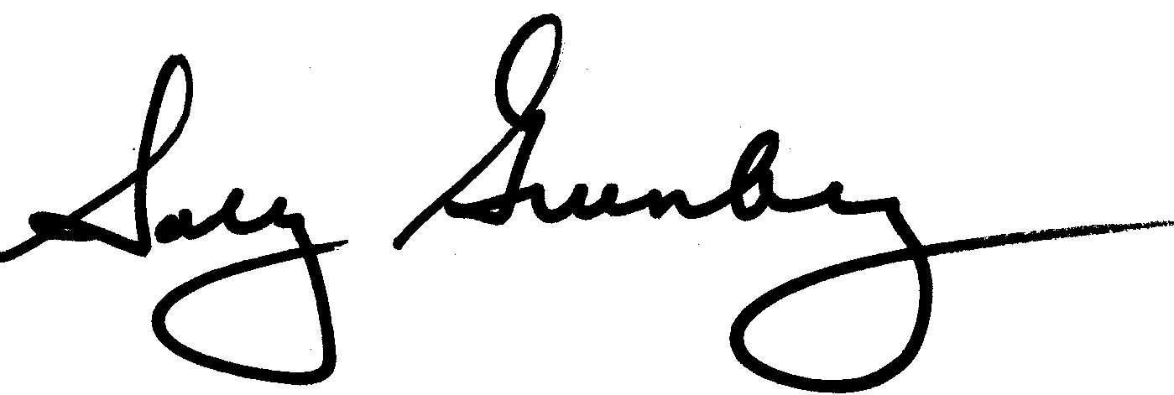

“The unit-price is right: advocates commend large retailers for agreeing to provide unit prices online – National Consumers League,” National Consumers League, June 18, 2014. https://nclnet.org/online_unit_pricing_release/
“Statement on NCL v. McCormick & Company, Inc. And Giant of Maryland LLC – National Consumers League,” National Consumers League, August 27, 2015. https://nclnet.org/ncl_v_mccormick/
“Corporate Profits,” Bureau of Economic Analysis, December 21, 2023. https://www.bea.gov/data/income-saving/corporate-profits
“Corporate profits have contributed disproportionately to inflation. How should policymakers respond?” Economic Policy Institute, April 21, 2022. https://www.epi.org/blog/corporate-profits-have-contributed-disproportionately-to-inflation-how-should-policymakers-respond/
“S.3819 - Shrinkflation Prevention Act of 2024,” Congress.gov, February 28, 2024. https://www.congress.gov/bill/118th-congress/senate-bill/3819/text
“When less is not more: Investigating US consumer awareness of shrinkflation,” YouGov, April 3, 2023. https://business.yougov.com/content/46409-when-less-is-not-more-investigating-us-consumer-awareness-of-shrinkflation
“Americans are noticing shrinkflation, and they’re not happy,” Ipsos, June 12, 2023. https://www.ipsos.com/en-us/americans-are-noticing-shrinkflation-and-theyre-not-happy

