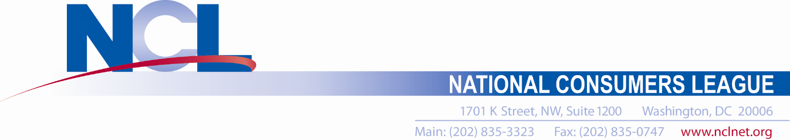
Lkkjlsdkjskjdkjs

Health Policy Associate -- Full Time

The National Consumers League (NCL) is a national nonprofit organization that has been protecting and promoting social and economic justice for consumers and workers in the United States since 1899. NCL seeks a motivated candidate for the position of associate to help carry out its health policy program. Reporting to the Director of Health Policy, the ideal candidate with have a strong background in research and writing for a variety of audiences. The associate will assist with the management of NCL’s health policy portfolio and engagement with policymakers on the state and federal levels. Candidates should have a strong commitment to serving the public interest.

Key Responsibilities
- Conduct public policy research, writing and editing for press statements, blogs, testimony, and congressional letters.
- Develop and maintain collaborative relationships with other consumer and public interest organizations and coalitions, health professionals, academic researchers, and industry.
- Assist with NCL’s Health Advisory Council meetings and newsletters, blogs, and statements.
- Lead the coordination of NCL’s Script Your Future Medication Adherence Team Challenge.
- Assist the Director of Health Policy in managing the work of interns.
- Provide logistical and administrative support for online and in person workshops, conferences, including scheduling meetings and conference calls, helping invited speakers and experts with travel and logistics, preparation and dissemination of materials, note taking at meetings, creating, updating, and maintaining organized files and records, and other related tasks.
- Create and format spreadsheets, tables, charts, presentations, and other graphics.

Qualifications
- Bachelor’s degree
- At least 2-3 years of experience working on health care policy and issues, particularly on the Hill, at a federal agency, think tank, or progressive public interest organization
- Superb research and written communication skills
- Excellent organization skills, strong attention to detail, ability to work on multiple projects simultaneously
- A self-starter able to work independently in a fast-paced environment
- A demonstrated commitment to improving public health and health equity

Salary and Benefits
Salary based on experience and education competitive with other nonprofit public interest organizations. Excellent benefits, including health, dental, short and long-term disability, life insurance, 401(k), employer transportation contributions, flex time, annual and sick leave, and federal holidays. NCL is an equal opportunity employer.

To Apply
Please submit cover letter, résumé, and writing sample to ncljobs@nclnet.org and reference “Health Policy Associate” in the subject line. If selected for hire, candidates must agree to undergo a background check.

