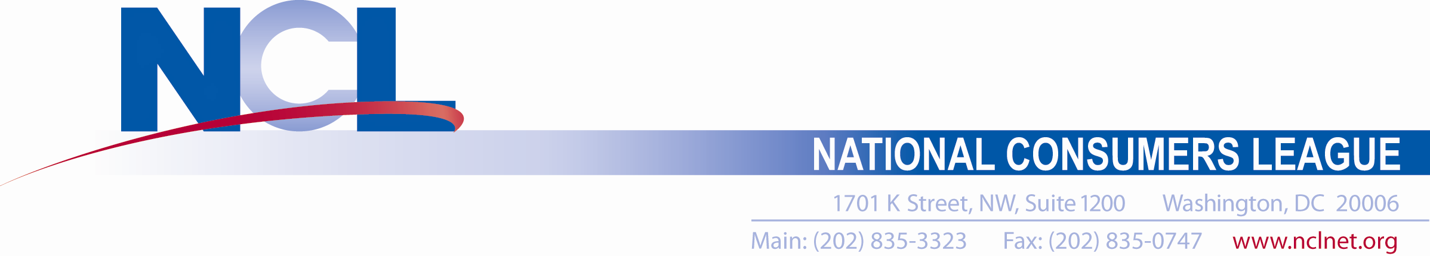

May 18, 2023

Dear DC Councilmember:

The National Consumers League, founded in 1899, has had a longstanding mission to advance the interests of both workers and consumers. NCL, with headquarters in Washington DC and with many staff residing in the District, was instrumental in amendments to the DC Consumer Protection Procedures Act that strengthen the statute and make the law one of the strongest in the United States. We regard any attempt to carve out whole industries from being held accountable under the DC CPPA as ill-advised and dangerous.

That is why we are writing to urge you to vote reject a bill scheduled for a hearing on June 8, 2023 before DC Council Bill 25-0280, the “Workers and Restaurants are Priorities Act of 2023.” Our analysis of this bill is that it is both anti-consumer and anti-worker, and sets a dangerous precedent for carving out an exemption to our DC CPPA consumer protection law for the sole protection of restaurants.

Specifically, section 3 of Bill 25-0280 says:

“(nn) The imposition of a service charge by a restaurant or bar, imposed as a percentage of sales, shall not be an unfair or deceptive trade practice, provided the consumer is advised of the charge in advance of ordering food or beverages, verbally, by signage in the establishment reasonably visible upon entry to the establishment or on any website of the establishment.” (italics added).

In short, this provision would essentially bless restaurants’ who are charging service fees on top of patrons’ bills without explaining the purpose of those fees, notwithstanding the very real issue of consumers confusing service fees with tips (the legislation defines service fees to include fees used to support employees’ base wages—i.e., it allows charges to be used for very different purposes than a tip). This “safe harbor” exemption would give unprecedented protection for false and deceptive practices on the part of restaurants so long as the existence of the service fee is disclosed; there is no obligation for restaurants to explain where the funds will actually go, even though that information is material to consumers’ spending and tipping decisions.

In addition, the legislation sets an extremely low bar for how service fees can be disclosed that is inconsistent with the case law requiring prominent disclosure of material information. This “safe harbor” would apply so long as the service fee is disclosed verbally, through signage, or just on the website. In other words, the disclosure could be buried in fine print on an obscure page on the restaurant’s website, and the immunity would be triggered.

We are also concerned with what appears to be a deliberate attempt to hide the troubling language in Section 3. The bill’s description, if one clicks on the link above, says only that Council Bill 25-0280 “sets minimum standards for third-party delivery platforms, exempts sales tax on service charges, modifies the way rents for restaurants are calculated, accelerates the timeline for I-82 implementation, creates a public awareness campaign regarding I-82 implementation, establishes safeguards for food delivery workers, and mandates a study on delivery worker conditions.” This is a misleading description, as it fails to disclose that the bill also proposes to completely exempt the restaurant industry from the DC CPPA consumer protection law, which requires employers to fully describe to consumers how service charges or fees are being used, and then use the service charges exactly as promised to consumers. It also provides sales tax exemption to all restaurants that use service charges, rather than limiting tax exemptions to restaurants that actually pass along service charges to workers, a provision we would support.

As for the bill’s troubling provisions affecting workers, since the passage of Initiative 82 last year, we have been concerned that the Restaurant Association of Metropolitan Washington (RAMW) has been advising restaurant owners to switch from tips to service charges, and then use a portion of the service charge - which many consumers assume goes to workers - to cover their own costs of the wage increase mandated by I-82. Those costs are not tips! DC Consumer law requires that these restaurants disclose how they are using the service charge, and then use it exactly as disclosed. Our concern is that RAMW is seeking to absolve restaurants of this requirement so that they can use the service charges exactly as they choose without providing transparency to consumers, and without the accountability of passing along what should be gratuities to workers.

Carve-outs for any industry in a critical consumer protection bill like the DC CPPA are unacceptable, and are a slippery slope. In this context, they are particularly problematic as consumers eating have reported being very confused about service charges they are seeing on restaurant bills in the District. Consumers want to know that service charges are being passed along to workers, as they assume, rather than being asked to tip on top of service charges that have taken the place of tips they previously paid.

Instead, if we want to support responsible restaurants’ transition to service charges, we should support only allowing sales tax exemption for restaurants that fully disclose on restaurant menus that they are passing the service charges entirely to workers, as consumers expect them to do.

We would be happy to provide any additional information - please let us know what else would be helpful.

Sincerely,

Sally Greenberg
CEO
National Consumers League
1701 K Street, NW #1200
Washington, DC 20006

